# **StreetCraft Sneakers**

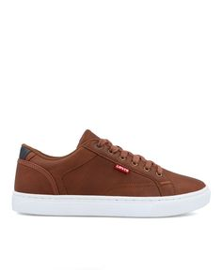Product Details:

Color: The Levi's UrbanChic Sneakers feature a distinctive color scheme with rich chocolate brown and earthy taupe.

Sole: The sole is a crisp white, providing a clean contrast to the rich tones of the upper.

Material: Crafted from high-quality synthetic leather and durable textile materials, ensuring longevity and style.

Closure: Secure lace-up closure system for a personalized and secure fit.

Branding: The iconic Levi's logo is prominently displayed on the tongue and side, adding a touch of brand recognition and authenticity.

Comfort: Padded collar and cushioned insole provide exceptional comfort, making them suitable for extended wear.

Style: The Levi's UrbanChic Sneakers offer a unique blend of urban edge and contemporary style, making them stand out from the crowd.

Occasion: Versatile enough for various occasions, from casual outings to urban adventures.

Versatility: Pair with jeans, joggers, or even a casual dress for a stylish and fashion-forward look that reflects your individuality.